**Katiba Demystified**

**Project Lead**: Kennedy Mwendwa

**Team Members**:

Kennedy Mwendwa – Software Engineer

Sandra Wanjiru – IT Specialist

Mentor: Abdul

**Problem Background**

In Kenya, many citizens remain unaware of their constitutional rights and how to enforce them. A 2015 report by AfriCOG revealed that a significant portion of the population lacks the knowledge needed to engage effectively with the country's legal framework. Specifically, 52% of respondents in a pilot study expressed difficulty in understanding the Constitution due to its complex legal language and jargon. This knowledge gap hinders citizens from actively participating in governance and defending their rights.

The need for a simplified resource becomes even more pressing when we consider that the Constitution is the cornerstone of any democratic society. Without access to clear, understandable information, citizens are left vulnerable, unable to hold their leaders accountable or exercise their legal rights effectively. This issue persists largely because no user-friendly platforms exist that present the Constitution in simple, accessible language. Moreover, the high literacy levels required to interpret such a document further complicate its accessibility.

Despite ongoing civic education efforts, no platform has effectively simplified constitutional information for the general public. Programs designed to raise awareness often fail to break down complex legal terms into digestible content. Traditional educational approaches remain inaccessible to many due to language barriers, lack of resources, and limited interactivity. This highlights the growing need for tech-driven solutions that can simplify the Constitution for the average Kenyan citizen.

Several initiatives like constitution.net and finanace bill gpt have aimed to raise awareness about civic rights, particularly targeting specific groups such as women and students. However, these programs often focus on narrow segments of the population and are sporadic in nature, lacking the continuity and accessibility that a digital platform could provide. The major gap lies in the absence of a comprehensive, user-friendly digital solution that could demystify the Constitution and make it more understandable and accessible to all Kenyans.

**Research Questions**

* How might we design and implement a digital platform to demystify the Constitution for everyday Kenyans?
* How can we measure the effectiveness of this platform in raising constitutional awareness?

# Market Opportunity

## Current Alternative Solutions

ConstitutionNet: This platform provides resources for understanding and discussing constitutional matters but is largely tailored for legal professionals or civic educators rather than the general public. The language remains complex, and its user interface may be intimidating to everyday users who lack formal legal training.

FinanceBill GPT -It os only tailored to the FinanceBill 2024.

## What Needs to Be Added or Improved?

Simplified Content Delivery: Both current solutions fail to simplify the legal jargon enough for everyday users. While they focus on educating the public, their platforms often assume a certain level of literacy or legal knowledge, limiting their effectiveness in reaching a broader audience.

Continuous Engagement: Existing initiatives lack continuity in engagement, offering only intermittent touchpoints with citizens. There is a need for a sustained effort to keep citizens informed and engaged with constitutional matters over time.

## Leverage From the Gap

Katiba Demystified can capitalize on these gaps by offering:

User-Friendly Interface: A web-based platform that breaks down complex constitutional provisions into simplified, easily navigable sections. By doing so, it addresses the need for accessible, continuous engagement.

Interactive Features: Features like crowdsourced opinions and a discussion forum will ensure ongoing interaction, unlike the sporadic nature of current initiatives.

## Market Size

Affected Target Audience: The platform primarily targets the adult population in Kenya, estimated to be over 25 million people. Given that over 52% of respondents from a 2015 study found the Constitution difficult to understand, the immediate potential market comprises roughly 13 million people. Additionally, the growing number of young adults entering the workforce each year, coupled with increased internet penetration in Kenya, suggests that this market could expand as digital literacy improves.

Revenue Potential: The primary source of revenue for Katiba Demystified could stem from a combination of subscription models for enhanced features, partnerships with civic organizations, and advertising. In the first year, the platform is projected to generate over 20,000 site visits, with room for significant growth as civic awareness campaigns increase.

Economic Contribution: By raising constitutional awareness, Katiba Demystified could indirectly contribute to increased citizen participation in governance, leading to more transparent, accountable leadership. This civic engagement can stimulate more democratic processes, which in turn can foster an environment of political and economic stability, encouraging investment and growth in key sectors.

# Our Projects Solution

## Target User

The target users for this project are everyday Kenyan citizens who struggle to understand and engage with the legal framework of the country, particularly the Constitution. Our pilot study, which highlighted that 52% of citizens face difficulty comprehending the Constitution due to its complex legal language. Furthermore, citizens who are unable to interpret their rights are less likely to participate in governance or hold leaders accountable, making this target group critical for fostering civic engagement.

While the problem of constitutional understanding affects a broad swath of the population, the specific focus is on those without legal training, individuals from marginalized communities, and those with lower literacy levels. The decision to focus on this group stems from the fact that they are the most vulnerable when it comes to navigating the country's legal system and accessing their rights. While the problem could also indirectly affect legal professionals or civic educators, who may want to explain the Constitution to others, the direct and immediate need lies with the general public, making them the priority for this project.

# Solution Prototype

## Description of the Solution:

The solution is a web-based platform called Katiba Demystified, designed to simplify the Constitution for the Kenyan public. This platform breaks down the complex legal language of the Constitution into digestible, easily understandable sections, making it accessible to everyone regardless of their literacy levels or legal background. The platform provides key features aimed at enhancing user experience and interaction, including:

Login/Signup Options – Users can create accounts to personalize their learning journey and track their progress as they explore constitutional rights.

Explore Constitutional Sections – The Constitution is broken down into categorized sections (e.g., governance, individual rights, etc.), each explained in simple terms. Users can navigate through the content seamlessly, with additional resources like videos or infographics for further understanding.

Amendment and Feedback Mechanism – Users can propose suggestions for constitutional amendments and submit feedback on sections they find unclear, fostering active civic engagement.

Community Forum – A discussion space where citizens can ask questions, share insights, and collaborate on understanding specific constitutional issues. This forum will be moderated to maintain focus and clarity.

Resource Hub – Additional learning materials, including translated versions of constitutional clauses and case studies that illustrate the practical application of constitutional rights.

## Process Overview:

User Registration/Login – The first step is user authentication. This allows users to create an account or log in to an existing account, helping them track progress and receive personalized content.

Constitution Exploration – After logging in, users will navigate through the Constitution, which has been broken down into well-organized sections. Each section comes with an easy-to-read summary, additional explanations, and options to access further resources if needed.

Community Interaction – The platform encourages interaction among users through the community forum. Here, users can raise questions about the Constitution or share their opinions on various constitutional matters. The platform encourages discussions on key topics such as governance, human rights, and amendments.

Feedback and Amendments – Users can provide feedback on the clarity of certain sections, propose amendments, and participate in discussions on suggested changes. This helps foster active involvement in the constitutional dialogue.

Accessing Resources – The platform also houses various resources like case studies, videos, and translated content, ensuring that different learning styles are accommodated. This section helps users gain deeper insights into the real-world application of their constitutional rights.

This solution directly addresses the problem by simplifying the Constitution and making it both engaging and easy to access. By presenting complex legal terms in a user-friendly format, Katiba Demystified empowers Kenyans to understand their rights and engage more actively in governance processes. The ability to propose amendments and participate in discussions ensures the platform fosters democratic engagement, creating a space where citizens feel their voices are heard.

## Assumptions Made

In developing the Katiba Demystified platform, several assumptions were made:

That the Kenyan population has access to smartphones and internet connectivity – This assumption is based on Kenya's rapidly growing digital infrastructure and the increasing rate of mobile phone penetration.

That citizens are motivated to understand and interact with the Constitution – It is assumed that if the Constitution is made accessible and comprehensible, Kenyans will actively seek out such information.

That civic education programs have failed to adequately demystify the Constitution – Despite existing civic education efforts, the solution assumes that no effective platform currently simplifies the Constitution in a way that caters to the general public.

That citizens are willing to engage in online discussions about constitutional amendments – The platform assumes that users will participate in the amendment and feedback process if provided with an easy-to-use platform.

# Value Proposition

Katiba Demystified empowers everyday Kenyans by providing a simplified, easily accessible platform that demystifies the Constitution, enabling users to better understand their rights and engage in governance.

# Designed Solution

Katiba Demystified is a web-based platform designed to simplify the Kenyan Constitution, breaking down complex legal jargon into easily understandable language for the general public. It provides users with interactive features to enhance learning and engagement, such as a community forum for discussing constitutional issues and the ability to propose and vote on amendments.

## Technologies Used

React: The platform's front end is built using this technology to ensure a responsive, user-friendly interface. These choices were made to provide an intuitive experience across multiple devices.

NodeJs and PostgressSQL: For the backend, Node is used to manage server-side requests, while PostgressSQL stores the content of the Constitution, user profiles, and engagement data. These were chosen for their reliability and integration capabilities with web-based platforms.

API Integration: This was used to build an interactive way of access various parts of the constitution.

Screenshots of Main Modules

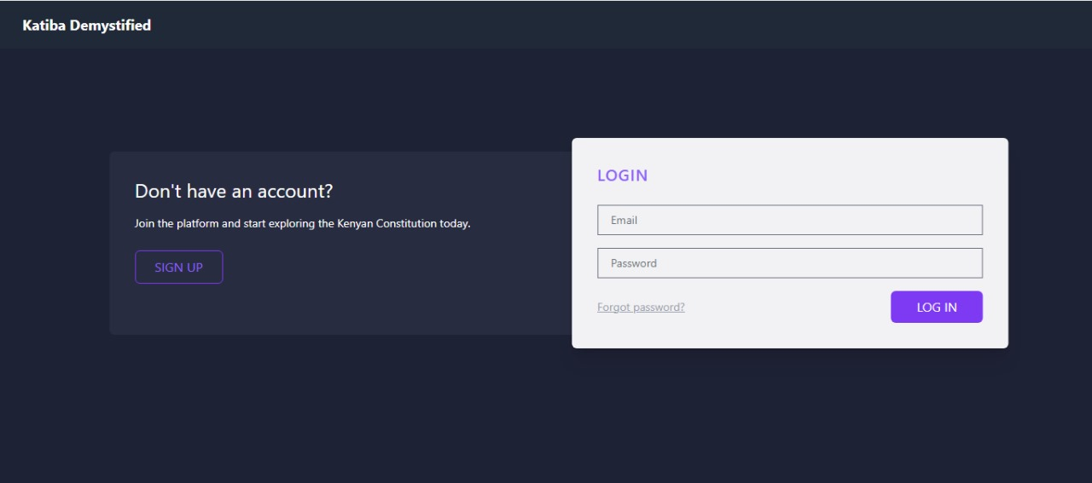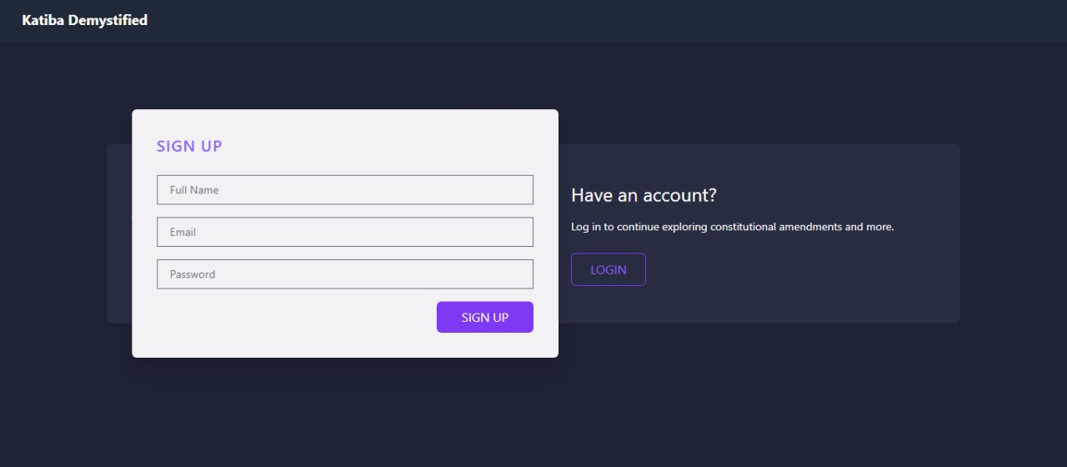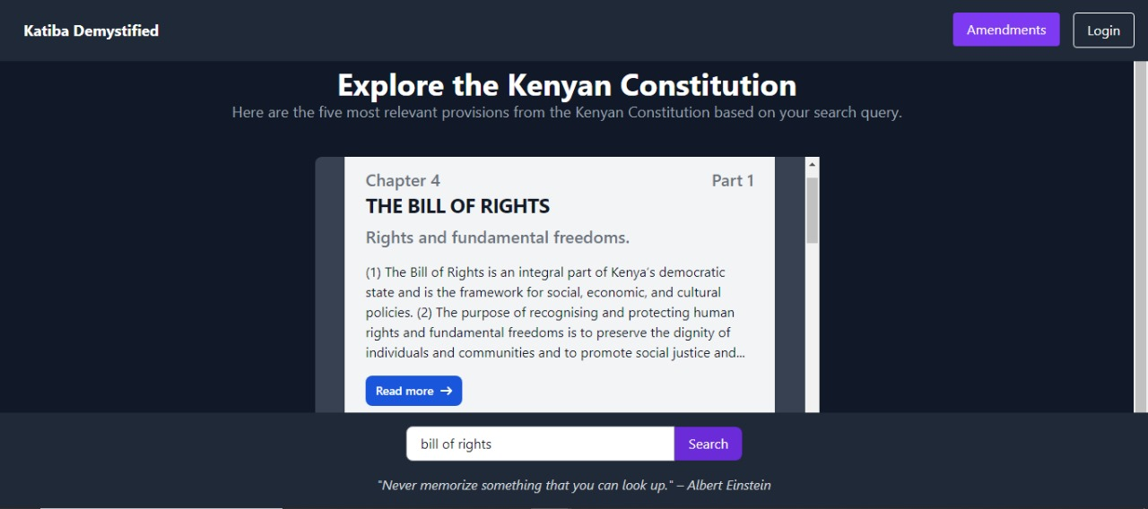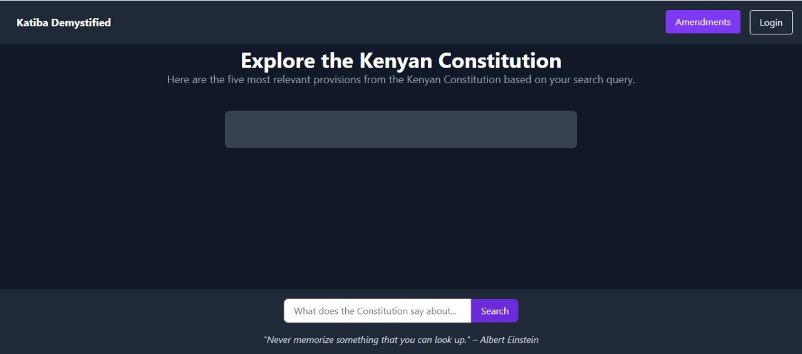

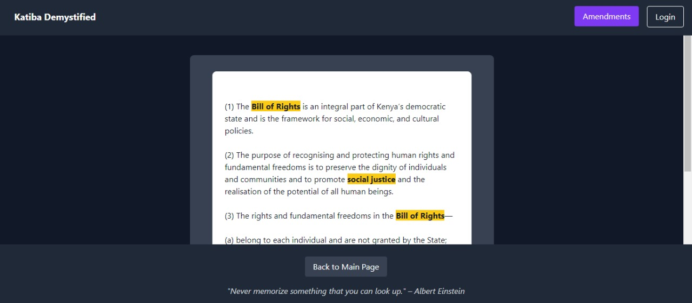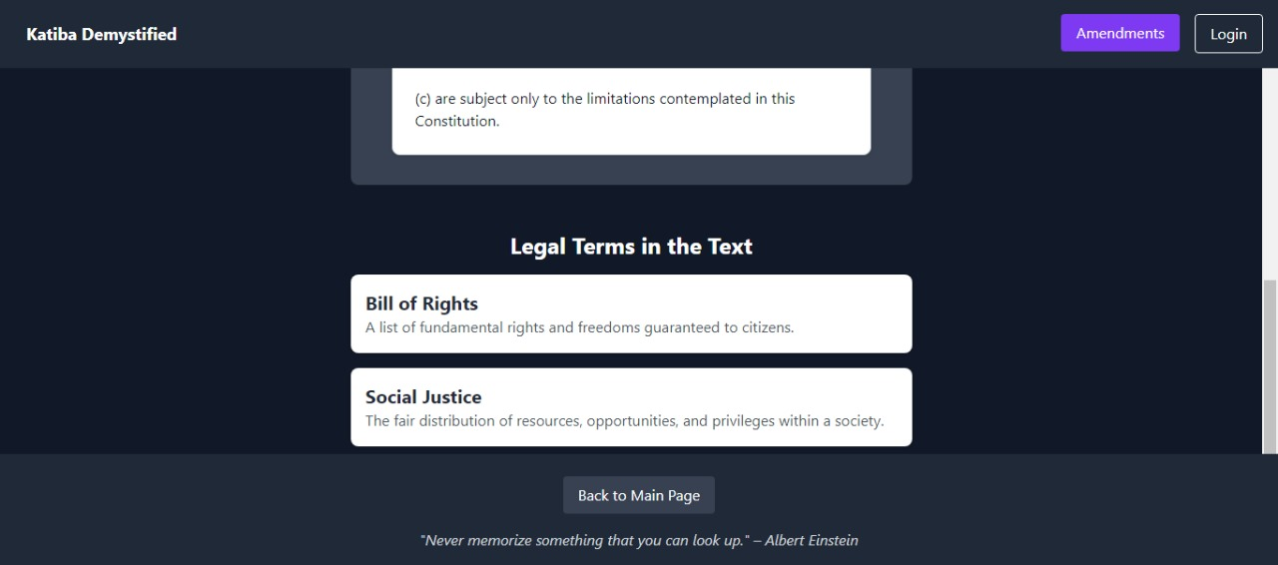

Login/Signup Module: Allows users to create and access accounts, personalizing their experience on the platform.

Explore Constitution Module: An easy-to-navigate section where users can explore constitutional articles and amendments, each broken down into simple language.

Community Forum Module: A space for users to discuss constitutional topics and propose amendments.

Feedback and Voting Module: Allows users to upvote proposed changes to the Constitution, fostering a participatory civic experience.

# Business Model

Katiba Demystified will generate revenue through a combination of approaches:

Partnerships and Sponsorships: Partnering with civic organizations, NGOs, and educational institutions to promote civic awareness, providing sponsorship opportunities.

Advertising: Limited, non-intrusive advertising targeting civic education and legal services may also generate revenue, maintaining a balance with user experience.

By using a combination of subscriptions and partnerships, we aim to ensure financial sustainability while maximizing user reach and engagement.

# Responsible Computing

Katiba Demystified adheres to responsible computing principles in the following ways:

Privacy and Security: User data is secured using encryption and only used to enhance the platform experience. No personal data is shared without explicit consent.

Accessibility: The platform is designed to be inclusive, with a focus on usability for people with limited tech literacy or those accessing the internet from mobile devices.

Inclusion-Katiba demystified can be used by anyone including those without legal knowledge.

Cultural sensitivity -The Katiba demystified content is made available to anyone who is a citizen of Kenya and it is made putting in mind a normal Kenyan thus it is easy to use and includes everyone.

Accountability-The Kenyan constitution is the sole source of information in this project.

# Traction

Potential Users: We have spoken to university students, civic educators, and community leaders who have expressed a strong need for simplified constitutional information.

User Engagement: We aim to have at least 50 beta testers by launch, ensuring the platform meets the needs of diverse users across Kenya.

Monetary Impact: The platform has not generated revenue yet, as it is still in the development phase.

**Funding/Support Need**

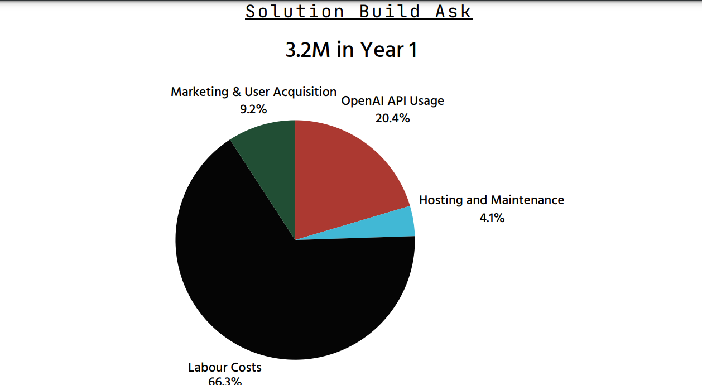

Funding Request for Pilot Stage Implementation (3 Years)

Total Funding Requirement: Ksh 10 million over 3 years

Year 1: Ksh 3.2 million

Market and User Acquisition: Ksh 1.4 million

Targeted campaigns to attract and retain users.

OpenAI API Usage: Ksh 2.0 million

Costs associated with utilizing the OpenAI API for enhanced functionality.

Hosting and Maintenance: Ksh 400,000

Ongoing hosting services and technical support for the platform.

Labour Costs: Ksh 400,000

Salaries for essential staff, including a project manager and technical support.

Year 2: Ksh 3.5 million

Market and User Acquisition: Ksh 1.5 million

Expanding marketing efforts based on Year 1 insights.

OpenAI API Usage: Ksh 2.2 million

Increased API usage to accommodate scaling operations.

Hosting and Maintenance: Ksh 600,000

Enhanced hosting capabilities to support growing user base.

Labour Costs: Ksh 200,000

Continued staffing for project oversight.

Year 3: Ksh 3.3 million

Market and User Acquisition: Ksh 1.5 million

Sustained efforts to maintain and grow the user base.

OpenAI API Usage: Ksh 2.0 million

Continued reliance on the OpenAI API for product functionality.

Hosting and Maintenance: Ksh 500,000

Upgraded hosting services for improved performance.

Labour Costs: Ksh 300,000

Final adjustments to staffing as the project scales.

Justification for Funding Needs

The requested funding aligns with the market values and necessary expenditures for the effective implementation of the pilot stage. The budget reflects competitive market rates for user acquisition, OpenAI API usage, and hosting services.

Market and User Acquisition: A substantial portion of the budget is allocated to marketing to ensure that the product reaches its intended audience. This includes digital marketing, social media campaigns, and community outreach efforts, critical for building a user base.

OpenAI API Usage: The cost of leveraging OpenAI’s capabilities is a significant investment to provide advanced functionalities, enhancing the overall user experience and product offerings.

Hosting and Maintenance: These costs ensure the platform remains operational, secure, and responsive to user needs.

Labour Costs: While the focus is on technology and user acquisition, skilled personnel are essential to guide the project through its pilot phase and beyond.

Post-Pilot Funding Needs

Following the pilot stage, additional funding will be required for full-scale implementation and sustainability of the project. An estimated Ksh 20 million will be needed for:

Scaling Up Operations: Ksh 10 million

Long-term Marketing and Community Engagement: Ksh 5 million

Continuous Evaluation and Improvement: Ksh 3 million

Contingency Fund: Ksh 2 million

This funding will ensure the project transitions from pilot to full implementation and establishes a sustainable operation capable of adapting to future challenges.

### Conclusion

The total estimated funding requirement of Ksh 10 million for the pilot stage is essential for successful implementation. The funds will facilitate comprehensive planning, execution, and evaluation, ensuring that we meet our objectives effectively and sustainably.

# Our Team

Our team comprises a diverse group of professionals with complementary skills essential for the successful implementation of the project. Our project manager possesses strong leadership and organizational skills, ensuring smooth coordination and communication among team members. The technical team includes software developers with expertise in AI integration and web development, enabling us to effectively utilize OpenAI's capabilities for our platform. Additionally, our marketing specialists bring experience in user acquisition strategies and community engagement, crucial for driving the project's visibility and growth. Together, our collective strengths and collaborative spirit position us well to navigate the challenges of the pilot stage and achieve our goals.